

Checklist Printing & Validation System

Maruti Suzuki India Ltd

User Manual

This user’s guide includes the information you need to work with the designed application. It contains detailed information about how the application will work.

Prepared By: Leena Patil
Version Number: V1.0
BAR CODE INDIA, 145 Udyog Vihar Phase I, Gurugram, Haryana-122016, PH: 0124 4337555

BAR CODE INDIA, 691 UDYOG VIHAR PHASE V, GURUGRAM, HARYANA - 122016, Ph.: 0124 4337555

Notice:
This document contains information, which is the proprietary property of Bar Code India. This document is received in confidence and its contents cannot be disclosed or copied without the prior written consent of Bar Code India.
Nothing in this document constitutes a guaranty, warranty, or license, express or implied. Bar Code India disclaims all liability for all such guaranties, warranties, and licenses, including but not limited to: Fitness for a particular purpose; merchantability; not infringement of intellectual property or other rights of any third party or of Bar Code India; indemnity; and all others. The reader is advised that third parties can have intellectual property rights that can be relevant to this document and the technologies discussed herein and are advised to seek the advice of competent legal counsel, without obligation of Bar Code India.
Bar Code India retains the right to make changes to this document at any time, without notice. Bar Code India makes no warranty for the use of this document and assumes no responsibility for any errors that can appear in the document nor does it make a commitment to update the information contained herein.

COPYRIGHT
Copyright © BCI 2023. All rights reserved.
TRADEMARKS
*Other product and corporate names may be trademarks of other companies and are used only for explanation and to the owners' benefit, without intent to infringe.

Revision History
Revision Number | Date | Prepared By | Reviewed By | Comment
1.0 | 17-03-2023 | Leena Patil | Prateek Khare | User Manual for Checklist Printing & Validation System of Maruti Suzuki India ltd.

Table of Contents

Revision History 0
1 Getting Started with Application 1
1.1 Introduction 1
1.2 Pre- Requisite for Application Working 2
1.3 Starting or Logging on the Application 2
2 Application Overview & Working 3
4 Application Modules 4
4.1 Login- Desktop Application 4
4.1.1 Desktop- Login 4
4.2 Dashboard 6
4.3 Managing Users and Rights 7
4.3.1 User Master 7
4.3.2 User Rights Master 10
4.3.3 Model vs Stamp Data Master 12
4.4 Transactions 13
4.4.1 Printing 13
4.4.2 Download Templates 16
4.5 Report 17
4.5.1 Result Details 17

Getting Started with Application

Introduction
The project is to develop and implement the Checksheet Printing and Validation System for MSIL that will facilitate the automation of manual process of writing inspection measurement results and stamp verification at Workstation.
This application will provide procedure to print QR Code label for Checksheet based on the applicable inspection result (OK Judge Value) fetched from MSIL Server against Vehicle Model & VIN Number. Once label is printed and pasted on Checksheet, it will pass through multiple inspection processes for stamping. A Vision System will be installed to verify stamping on Checksheet in order to ensure the completion of all processes with OK status.
The application will keep record of each activity transaction and maintain history logs for the same. The application will be integrated with MSIL Server in order to get applicable inspection result and to post required data in real time. The solution will be proved beneficial for MSIL as it aims to improve data accuracy, increase processing speed, eliminates paperwork and human dependency, reduces time & effort required for the activity and provide instant inventory and other types of pertinent reports.
The entire solution consists of followings:
- Windows Desktop based Application

Pre- Requisite for Application Working
[List all the necessary points or tasks that should have been performed to run the applications.]
Example:
- Desktop Application
  - Install the application on the Desktop.
  - System should fulfill the minimum requirement to run the Application.
- Communication Server:
  - Communication Server should be installed on server for Device and Database connection.
- Barcode Printer:
  - Barcode should be calibrated and connected with PC or on Network.

Starting or Logging on the Application
Windows Environment
To start Applications in the Windows environment double–click on an Applications icon.

Application Overview & Working

Application Modules

Login- Desktop Application

Desktop- Login
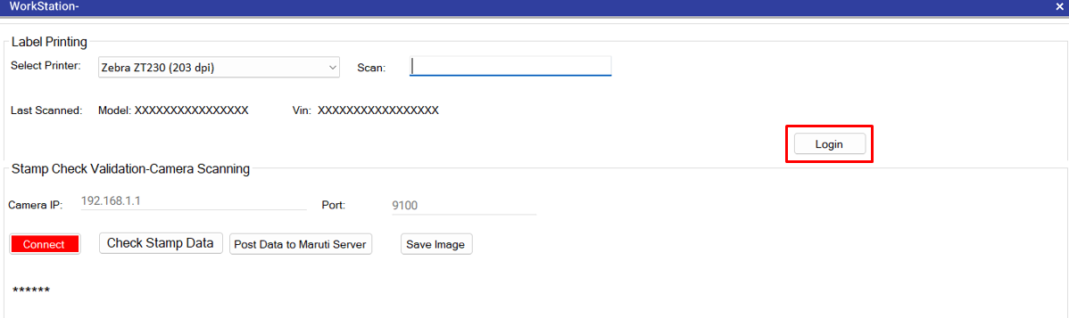
To access the desktop application, click on Login button from the Transaction screen of Label Printing.
Following login screen will appear:
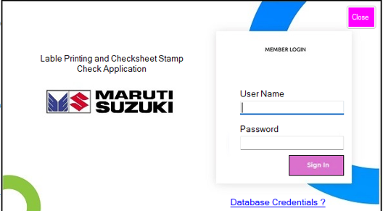
- Enter User Name and Password.
- Click on Login button to successfully login into the application and Dashboard will appear.
*In case a wrong User Name or Password is entered then an error message will be displayed.
*Only active users can login on this application.
*By default the login page will not be displayed initially. The transaction screen will be displayed initially and if the user want to change the master data and generate a results using report then only he can use the login screen.
Note: Please refer to Dashboard module – heading 4.2.
Please refer to Transaction module – heading 4.4.

Dashboard
By default the transaction screen will be displayed. User has to use login only to work on masters and reports.
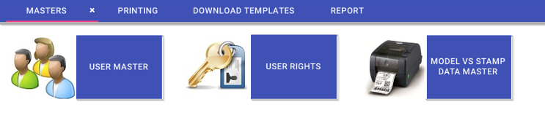
Masters
- User Master
- User Rights
- Model vs Stamp Data
Main Menu Options
- Printing
- Download Templates
- Report

Managing Users and Rights

User Master
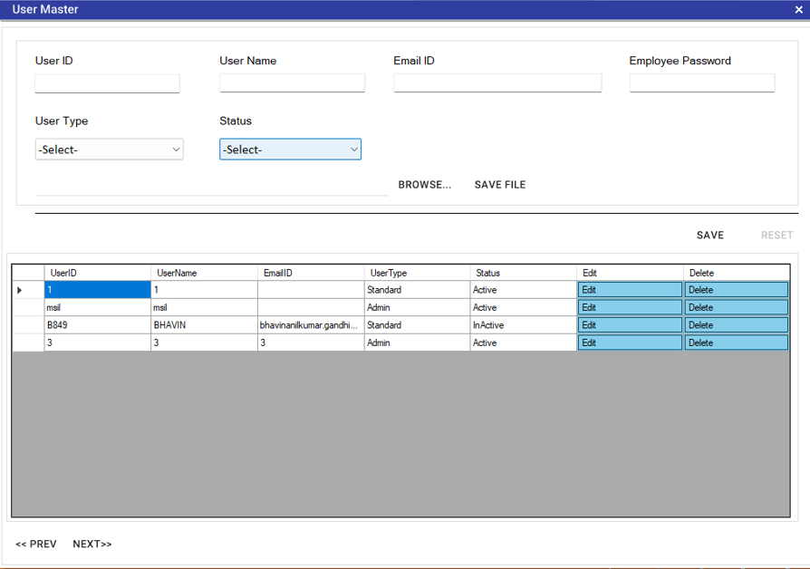
This module is used to add, update or delete an application User details. Click on Masters from the main menu and select User Master, following screen will get displayed:

Add User
- Enter User ID, User Name, Email ID and Employee Password.
- Select User Type and Status from the dropdown list.
- Click on BROWSE button to search user from collection of multiple users and import it.
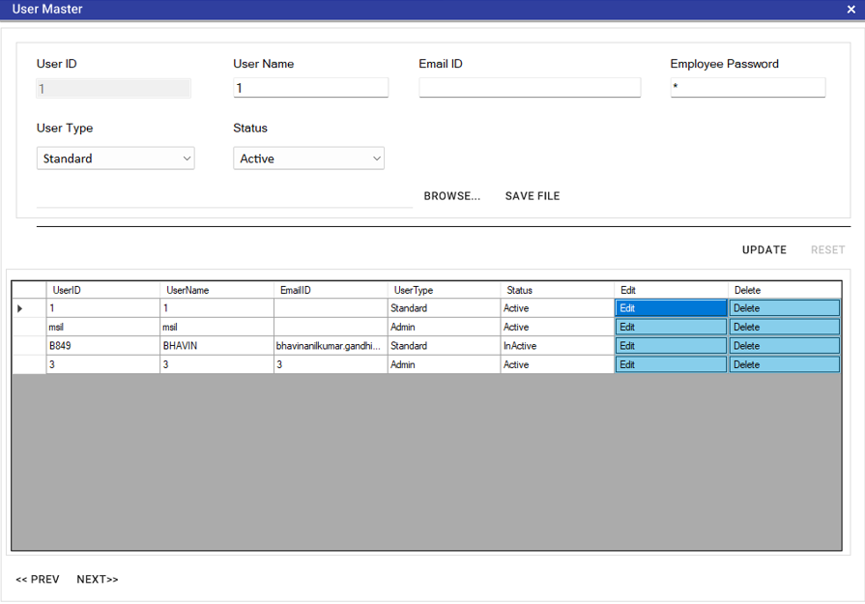
- Click on SAVE FILE button to save the browsed file.
- Click on UPDATE button, success message will get displayed if user details are saved successfully.
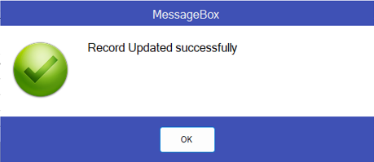

Edit and Delete User
- To edit user details, select user from the data grid and click on Edit
- Update required details and click on Update button to save the details.
- To delete User, select user from the data grid and click on Delete button.
- A confirmation pop up will appear on the screen.
- Click on OK button.
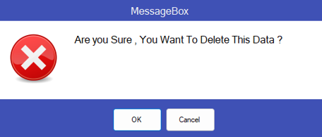

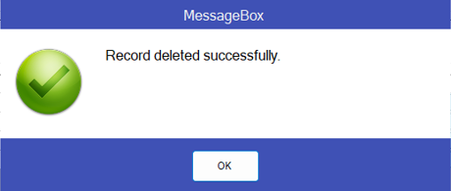
- A success message will get displayed if selected user is deleted successfully.

- Click on PREV or NEXT button to see the data grid of next page.

User Rights Master
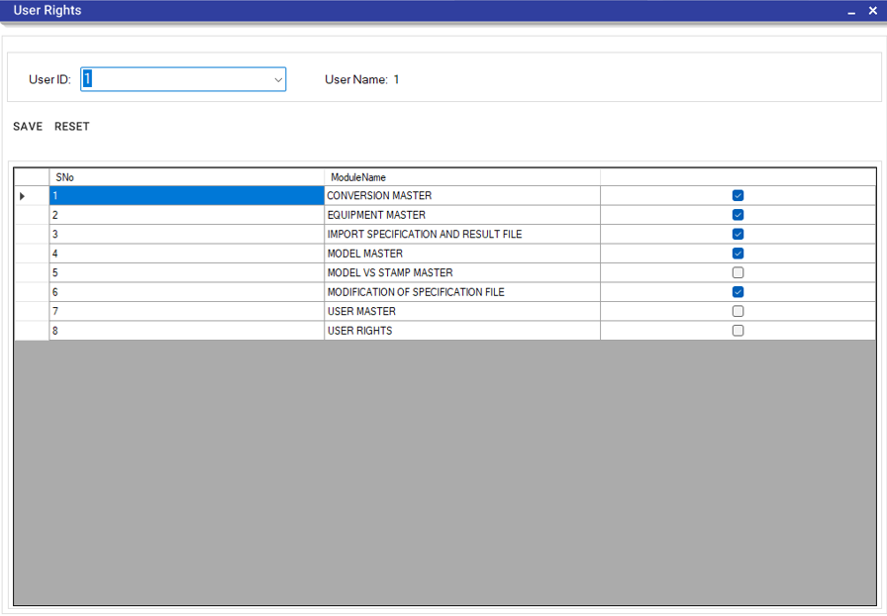
This module is used to assign access rights to the users. Click on Master from main menu and select User Rights, following screen will get displayed:
Assign Rights
- Select User ID from the dropdown list.
- User Name will be displayed on the screen.
- Modules Name along with the view checkboxes will be appeared in below grid.
- Click on checkbox against the Module Name for which you want to give access rights to the selected user.

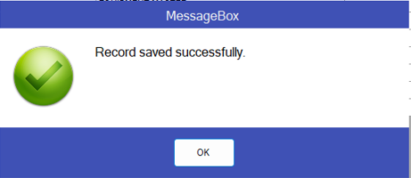
- Click on SAVE, success message will get displayed if rights are assigned successfully to the selected user.

- Click on RESET button to reassign the rights to user.

Model vs Stamp Data Master
This module is used to get the model vs stamp data. Click on Master from main menu and select Model vs Stamp Data Master, following screen will get displayed:
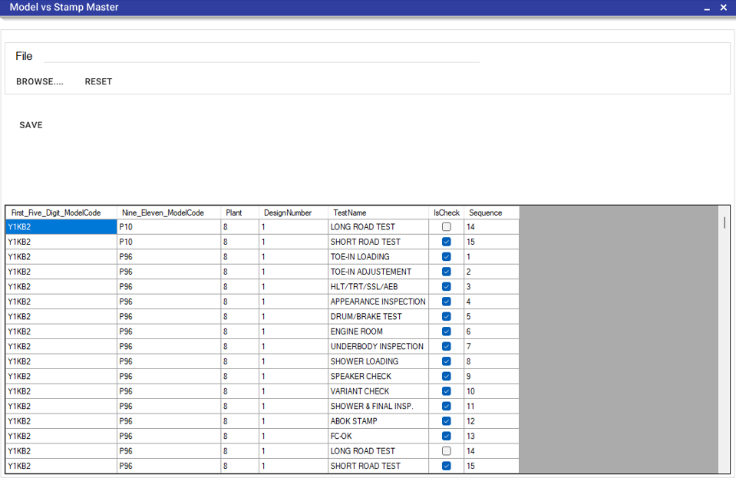
- A grid will be displayed on the screen with Test Name and its Sequence.
- Click on BROWSE button to select the excel file in the standard format.
- Click on SAVE button to save the data.
- Click on RESET button to save the new data.

Transactions

Printing

Printing
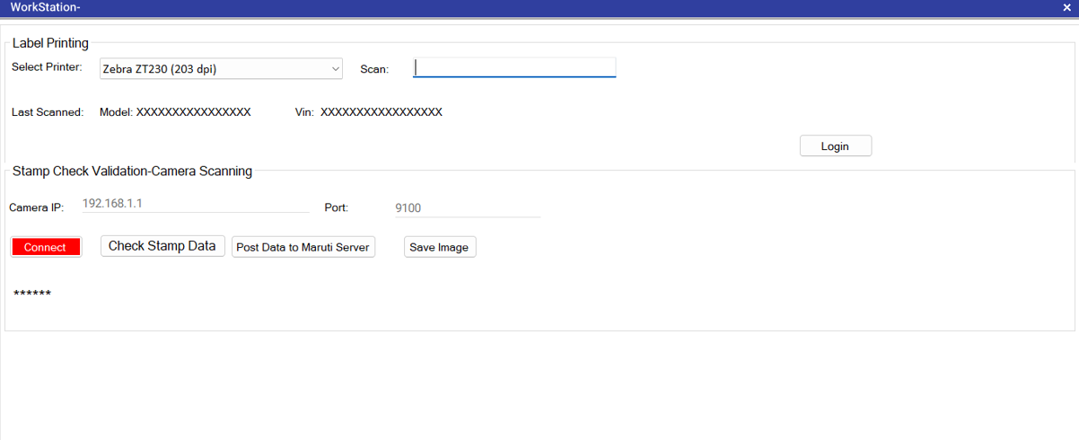
This module will be used for Checksheet QR Code Label printing. Click on Printing from main menu and select Printing, following screen will get displayed:
Add Label Printing
- Select Printer from dropdown.
- Scan Model in scan field.
- Scan Vin in Scan field.
*If the record is already printed then the pop up will appear on the screen for re-print. And user has to select Yes or No for re-print.
- Last scanned details of Model and Vin will appear on the screen.
- If the camera is connected then Camera IP and Port will be displayed on the screen by scanning.
- Click on Connect button to connect the camera.
*If the camera is connected then the Connect button will be shown in green color and if the camera is not connected then the Connect button will be shown in orange color.
- Click on Check Stamp Data button to verify if the data is correct or not.
- Click on Post Data to Maruti Server button to verify and post the data on Maruti’s server.
*Users can post the data to the server by pressing F2 shortcut key.
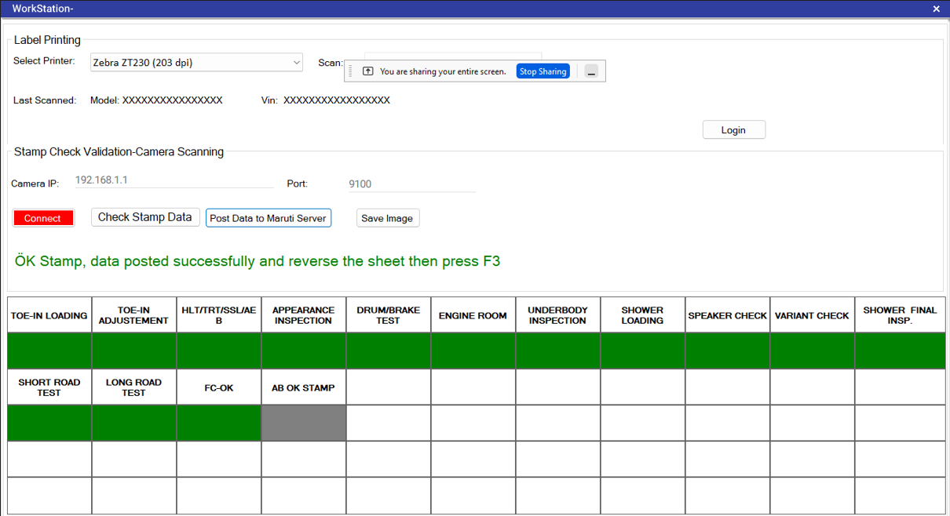
- A grid with all stamp details will be displayed on the screen as follows:
*If all stamps are correct then it will be shown in green color, if few stamps are bypassed then it will be shown in grey color and if the stamp is failed then it will be shown in red color.
- Reverse the sheet and click on Save Image button to save the image of sheet (from front and back side) in PDF format.
*User can save the image by pressing F3 shortcut key.

Re-printing
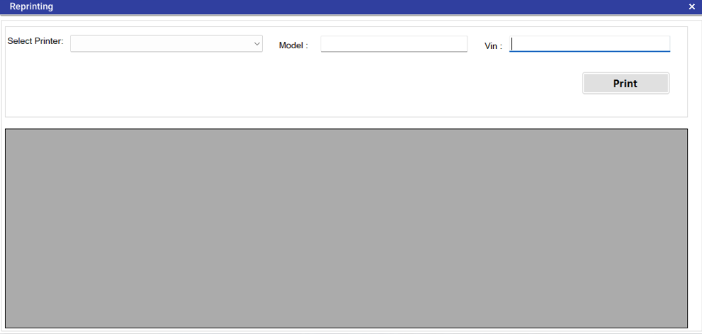
This module is used to re-print the Checksheet QR Code Label. Click on Printing from main menu and select Re-printing, following screen will get displayed:
- Select Printer from dropdown.
- Scan Model.
- Scan Vin.
- Click on Print button.
*Re-print is optional process.

Download Templates
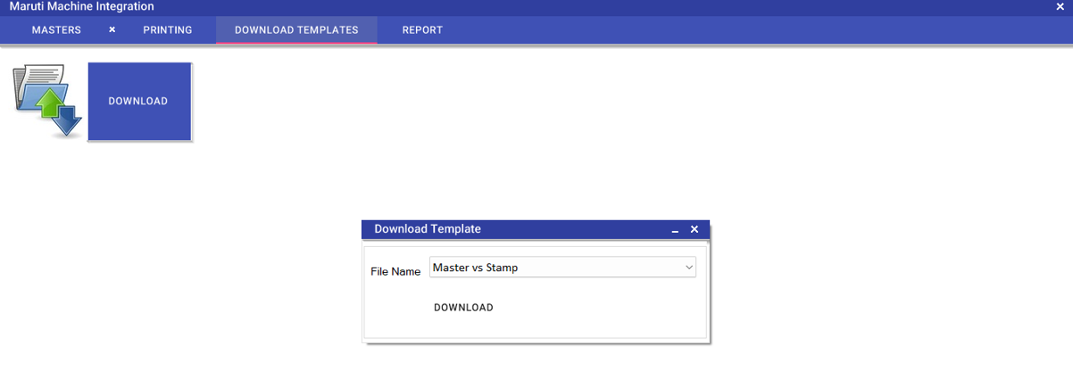
This module is used to download template of each module. Click on Download Templates from main menu and following screen will get displayed:
Template download
- Click on DONWLOAD button on the screen
- A pop will appear on the screen for Download Template.
- Select File Name from dropdown.
- Clock on DOWNLOAD button on the popup.
*The template will be downloaded on the machine.

Report

Result Details
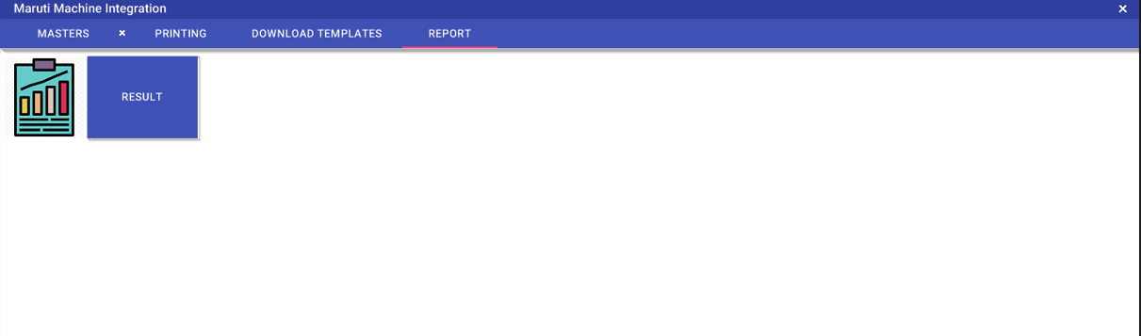
Users of Maruti Suzuki will be able to view and export the results in excel format from this module. Click on Report from main menu and following screen will get displayed:
View Results
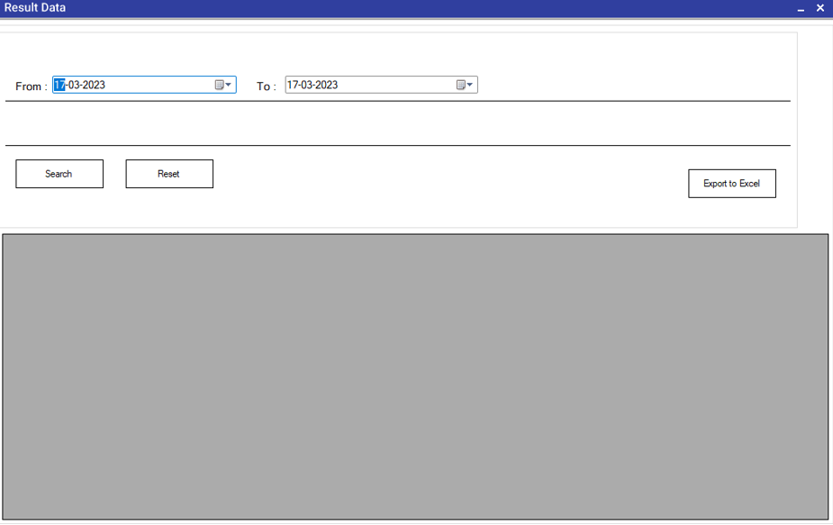
- Click the RESULT button on the screen and following screen will be displayed:
- Select From and To date from calendar for which the report is required.
- Click on Search button.
- A grid format of data will be displayed on the screen.
- Click on Export to Excel to download the data in excel format.
- Click on Reset button to change the dates and generate new report.

User Manual
[Maruti Suzuki India ltd- Checklist Printing & Validation System]
Confidential & Copyright©2023

